Author: Ajay Malik
Repo URL: https://github.com/ajaykuk/flask_Practice-main
Login to aws : aws login.

Link docker to ECR
aws ecr get-login-password --region <your-region> | docker login --username AWS --password-stdin <your-aws-account-id>.dkr.ecr.<your-region>.amazonaws.com
Tag local image:
docker tag <local-image-name>:<tag> <your-aws-account-id>.dkr.ecr.<your-region>/<your-repo-name>:<tag>
docker tag flask-student-app:latest 490600801130.dkr.ecr.us-east-1/flask-app:latest
Push local image to ECR:
docker push 490611801130.dkr.ecr.us-east-1/flask-app:latest

AWS
│
┌────────────┴────────────┐
│ │
GitHub Actions EC2
│ │
IAM Role: IAM Role:
GitHubActions-ECR-
FlaskStudentApp │
│
│ ├── AmazonEC2ContainerRegistryReadOnly
│ ├── AmazonSSMManagedInstanceCore
│ └── CloudWatchAgentServerPolicy
│
│ ECR Push │ ECR Pull
▼ ▼
┌───────────┐
│ ECR │
│ │
│ flask-student-app

└───────────┘

GitHub Actions
│
│ OIDC token
↓
AWS STS
│
│ AssumeRoleWithWebIdentity
↓
GitHubActions-Flask-ECR-Role
│
└──ECR Push
└── SSM Deployment

AWS Console → IAM → Roles → GitHubActions-Flask-ECR-Role → Trust relationships
{
"Version": "2012-10-17",
"Statement": [
{
"Effect": "Allow",
"Principal": {
"Federated": "arn:aws:iam::490600801130:oidc-provider/token.actions.githubusercontent.com"
},
"Action": "sts:AssumeRoleWithWebIdentity",
"Condition": {
"StringEquals": {
"token.actions.githubusercontent.com:aud": "sts.amazonaws.com"
},
"StringLike": {
"token.actions.githubusercontent.com:sub": "repo:GITHUB_USERNAME/REPOSITORY:ref:refs/heads/main"
}
}
}
]
}

Component | Role | Permission
EC2 | Existing EC2 role | AmazonEC2ContainerRegistryReadOnly
EC2 | Existing EC2 role | AmazonSSMManagedInstanceCore
GitHub Actions | GitHubActionsDeployRole | ECR push custom policy
GitHub Actions | GitHubActionsDeployRole | ssm:SendCommand
GitHub Actions | GitHubActionsDeployRole | ssm:GetCommandInvocation
GitHub Actions | GitHubActionsDeployRole | GitHub OIDC trust

IAM → Identity providers token.actions.githubusercontent.com
Provider: OpenID Connect
Audience: sts.amazonaws.com

WorkFlow:
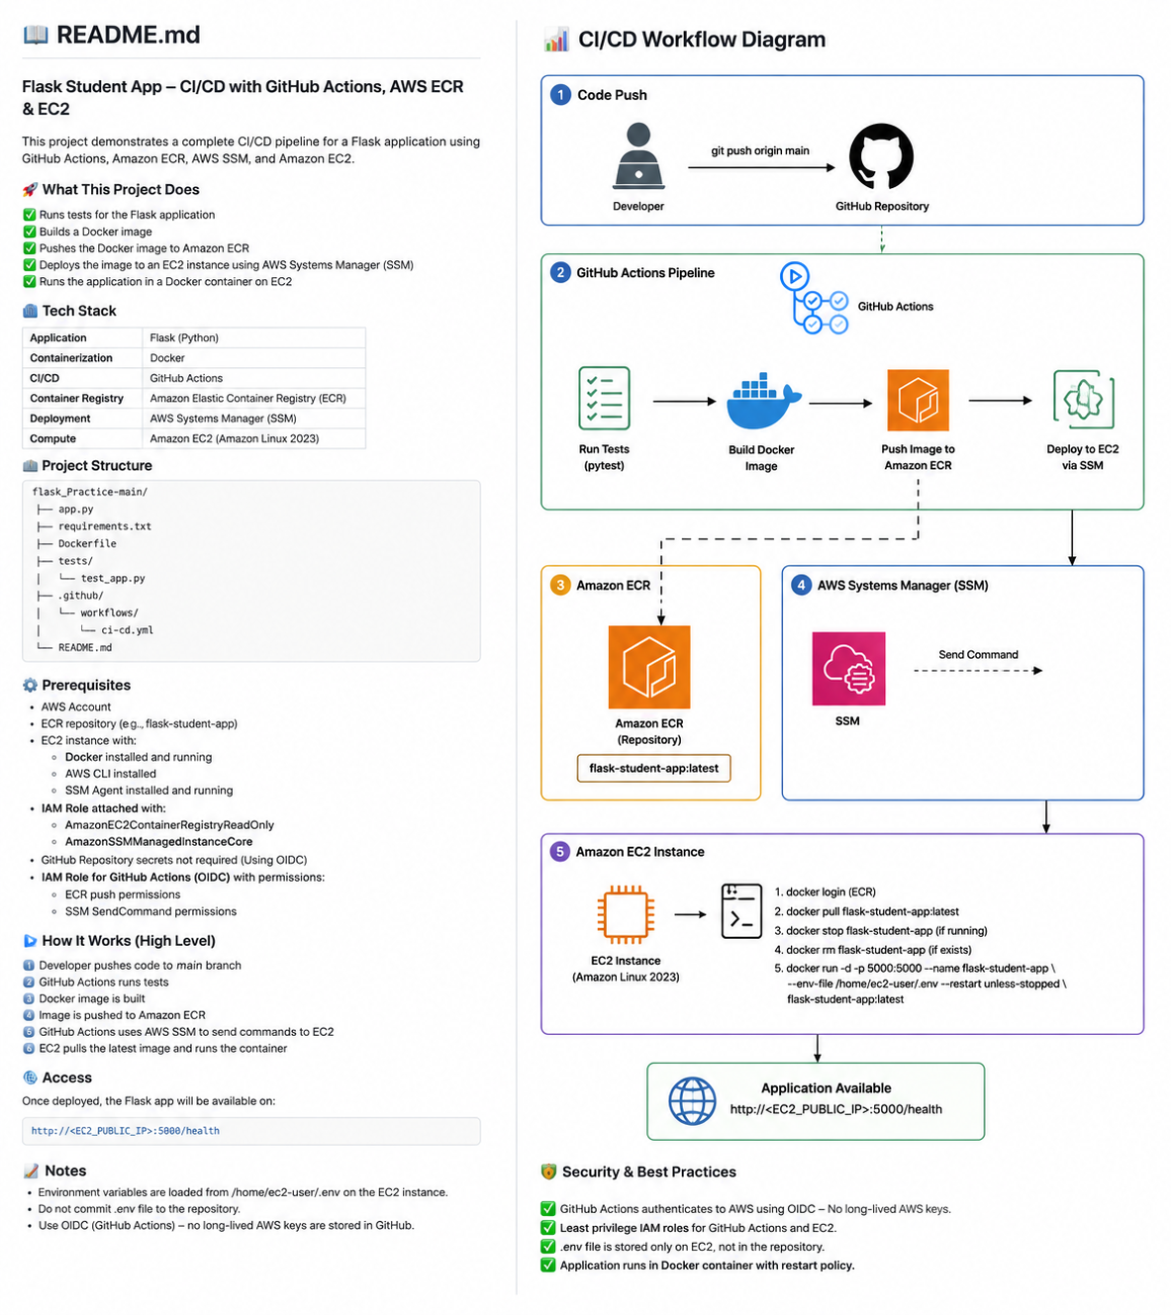

APP URL Screen print:

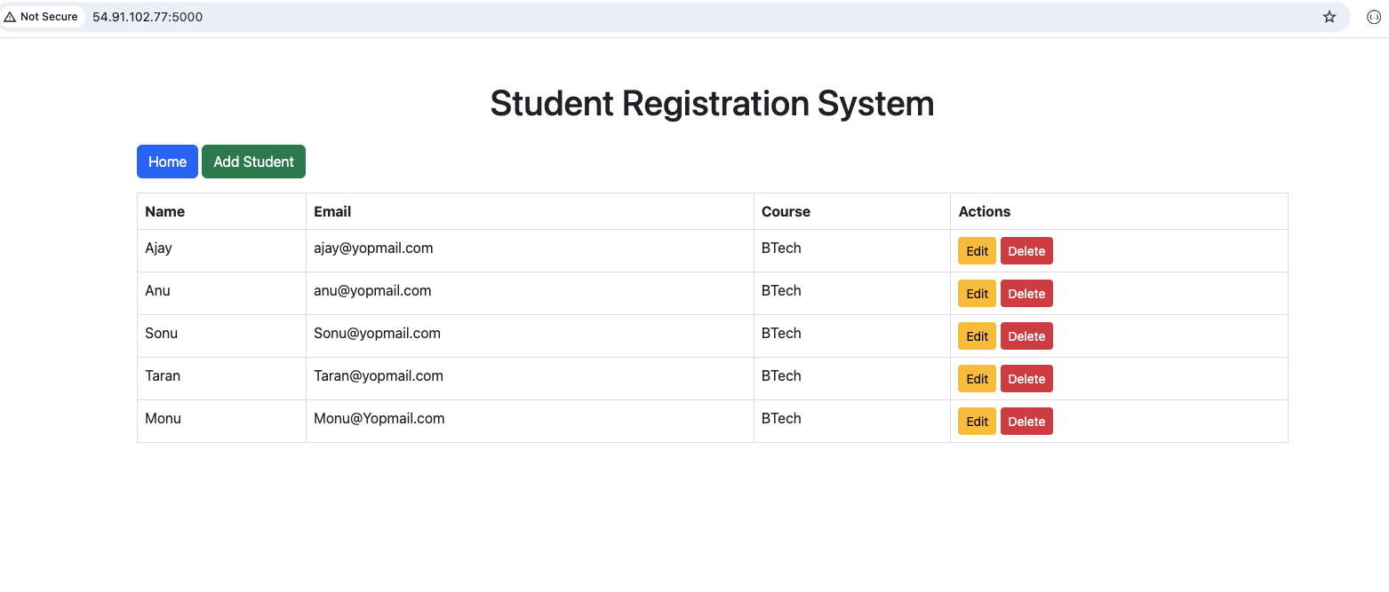

App Health URL Screen print:
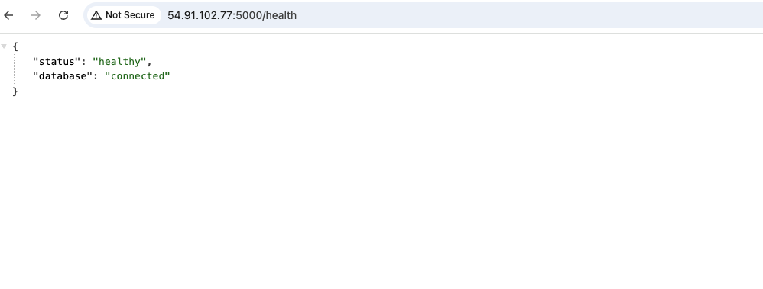
Image and Container ID:
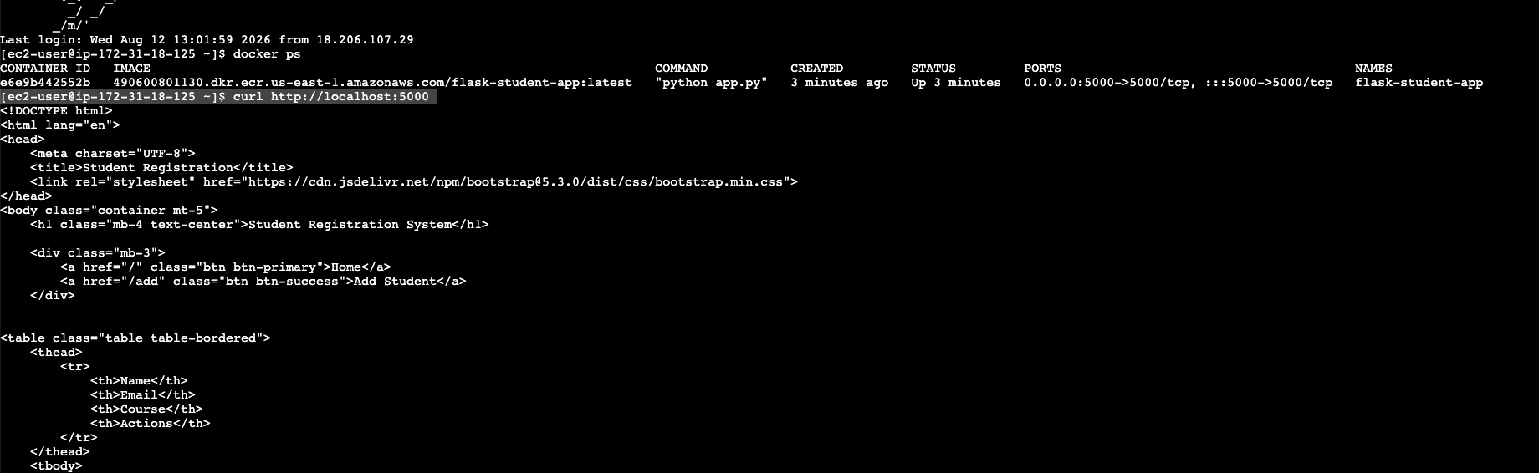

Run Tests Screenprints:
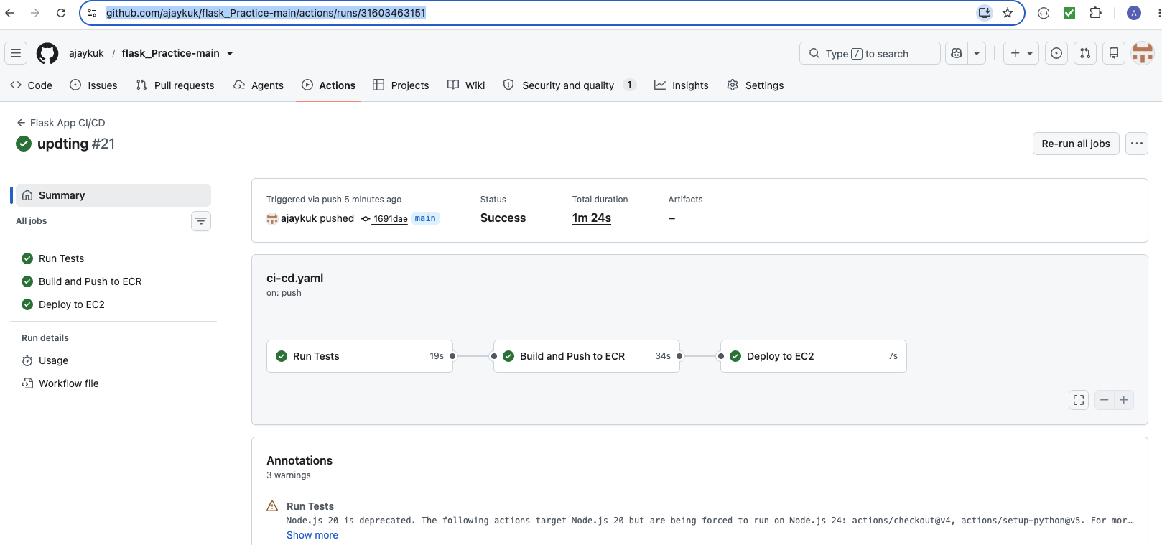
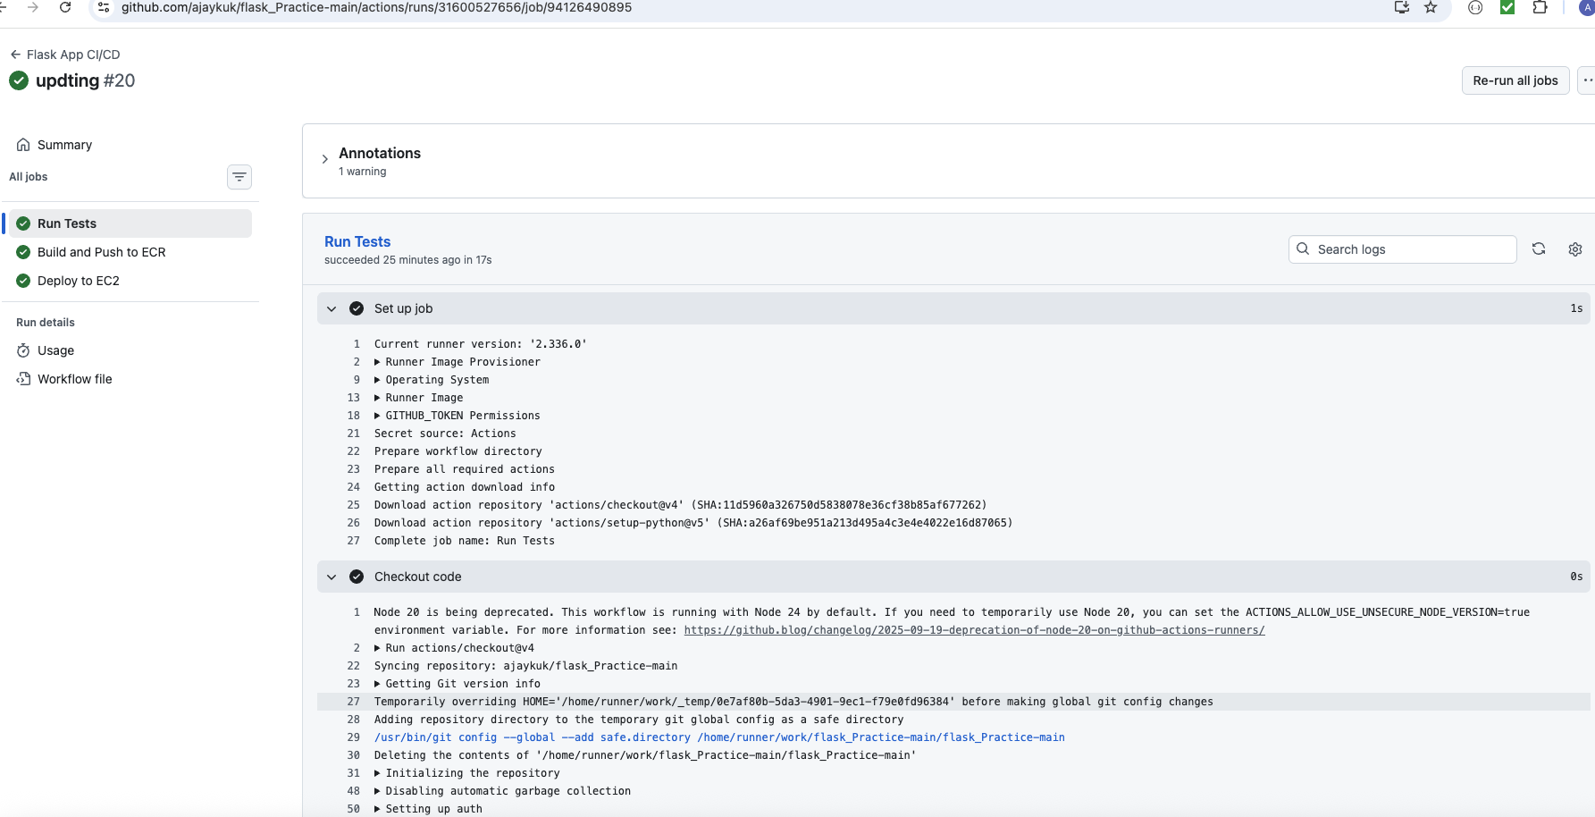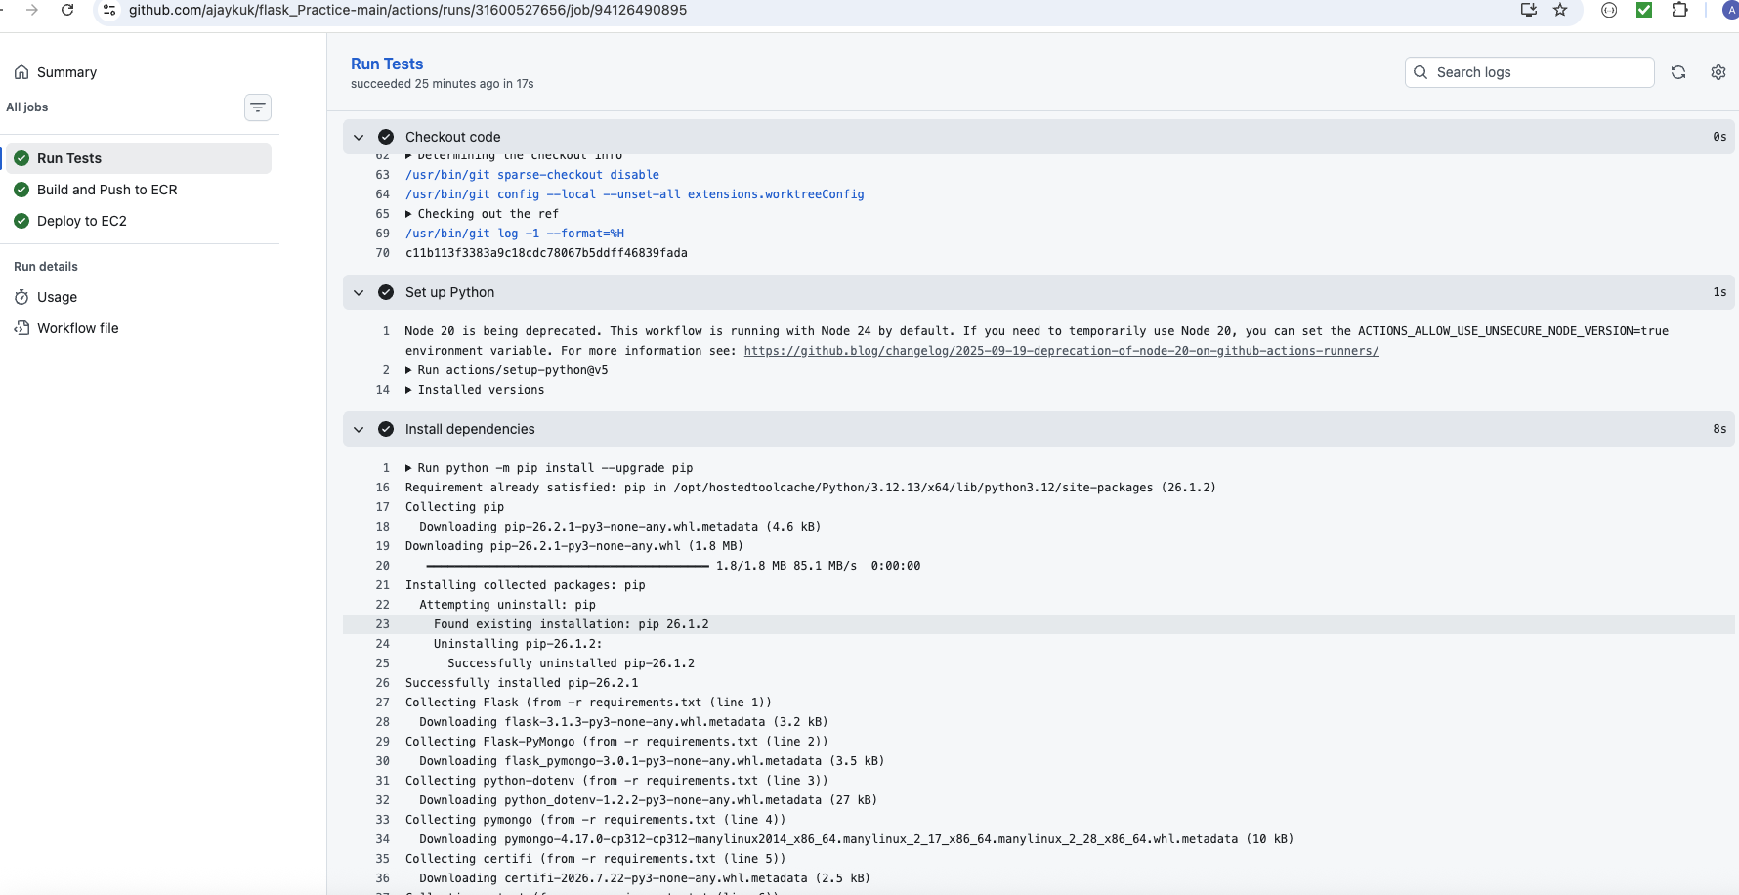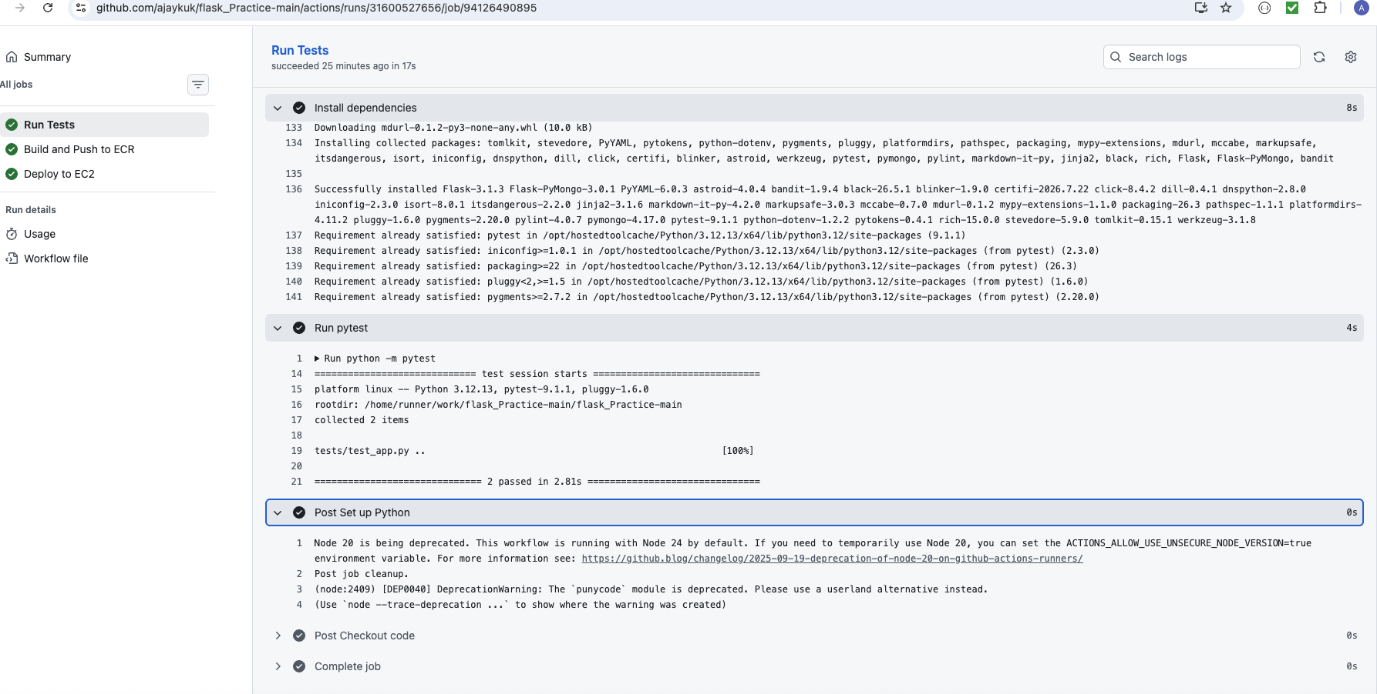

Build Pushed to ECR ScreenPrints:
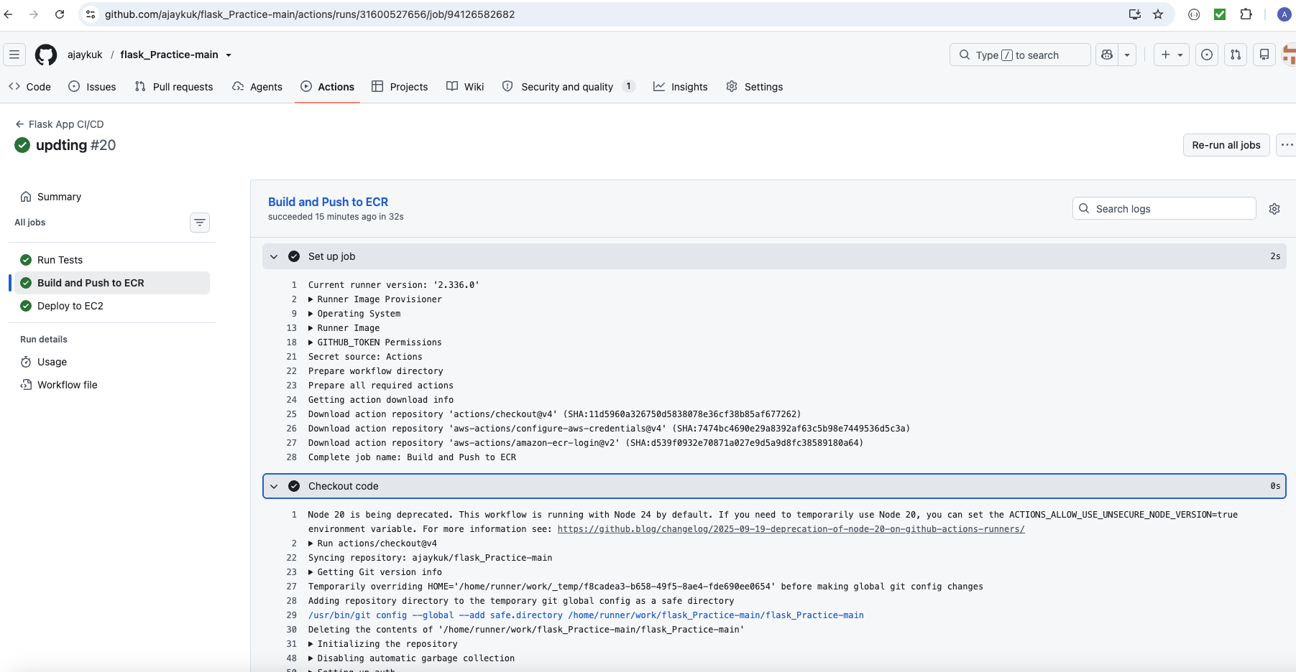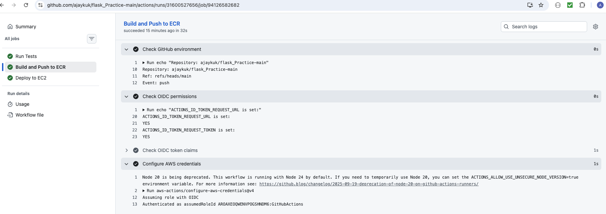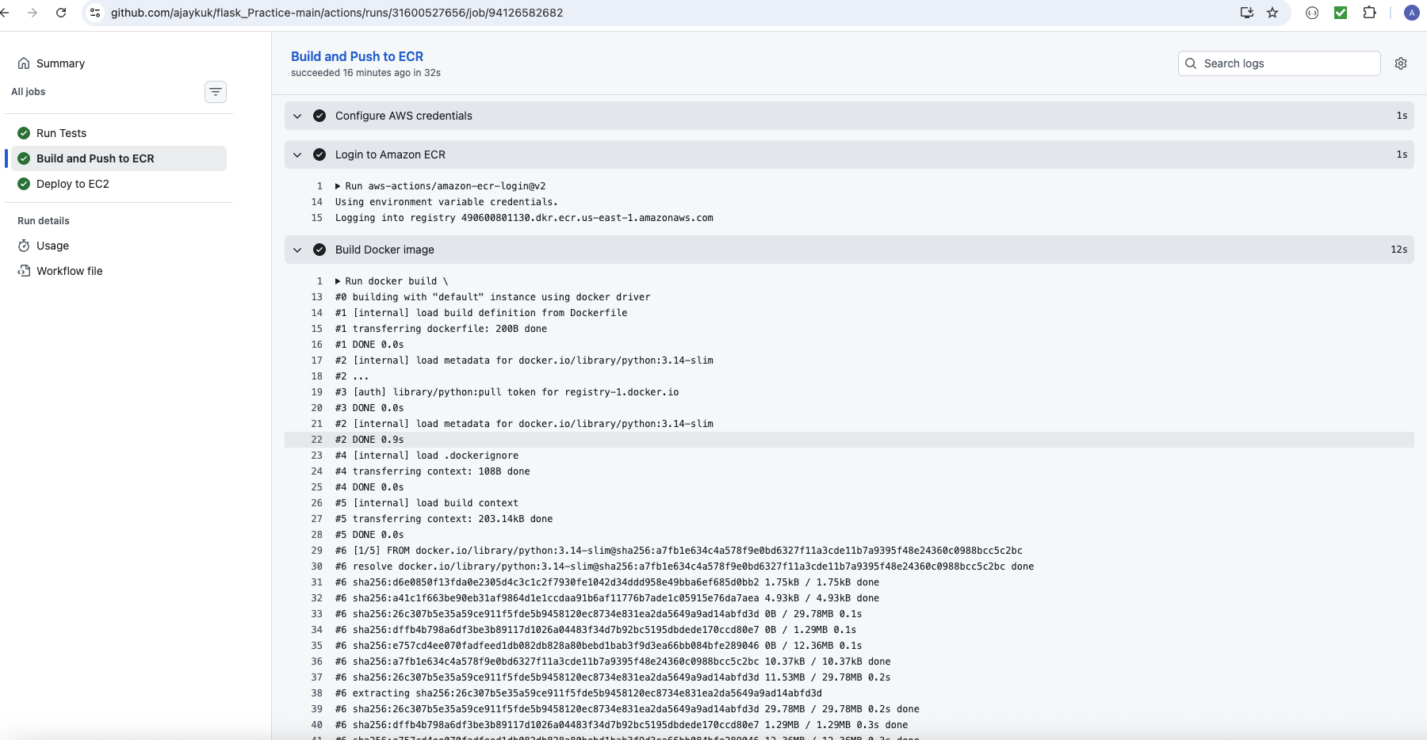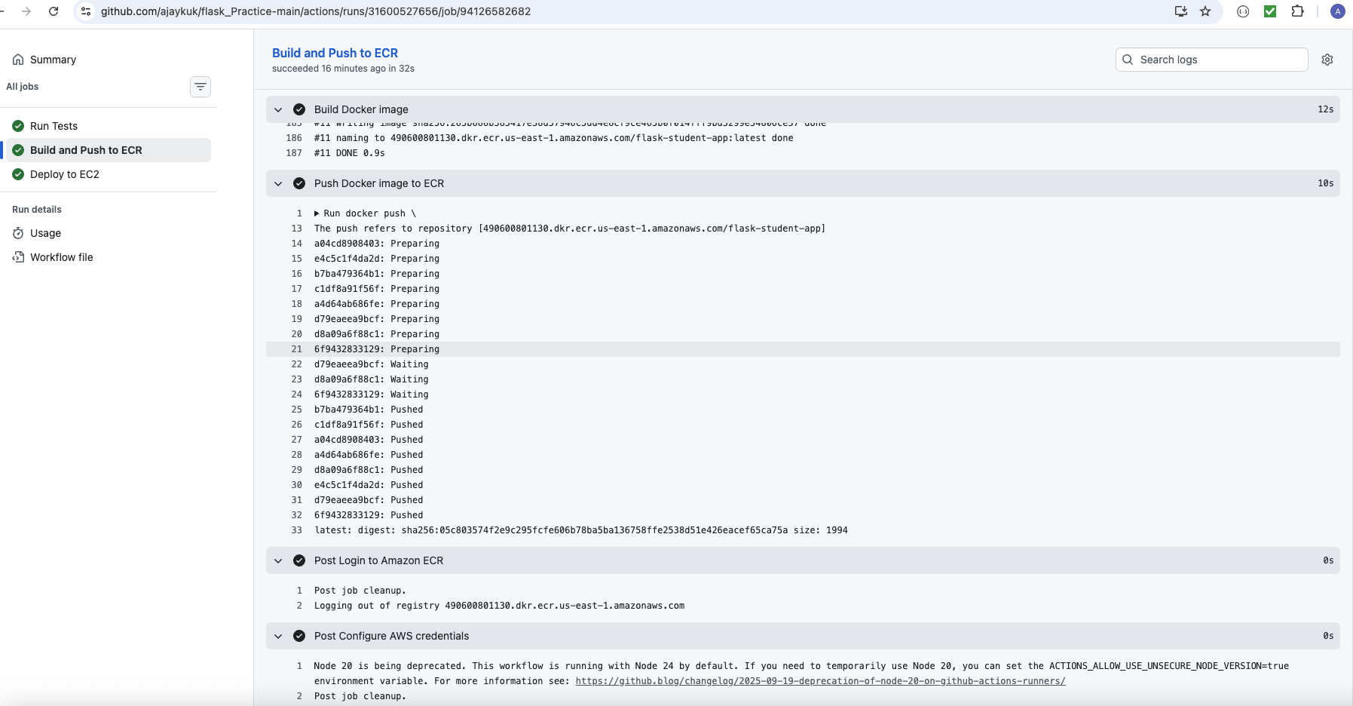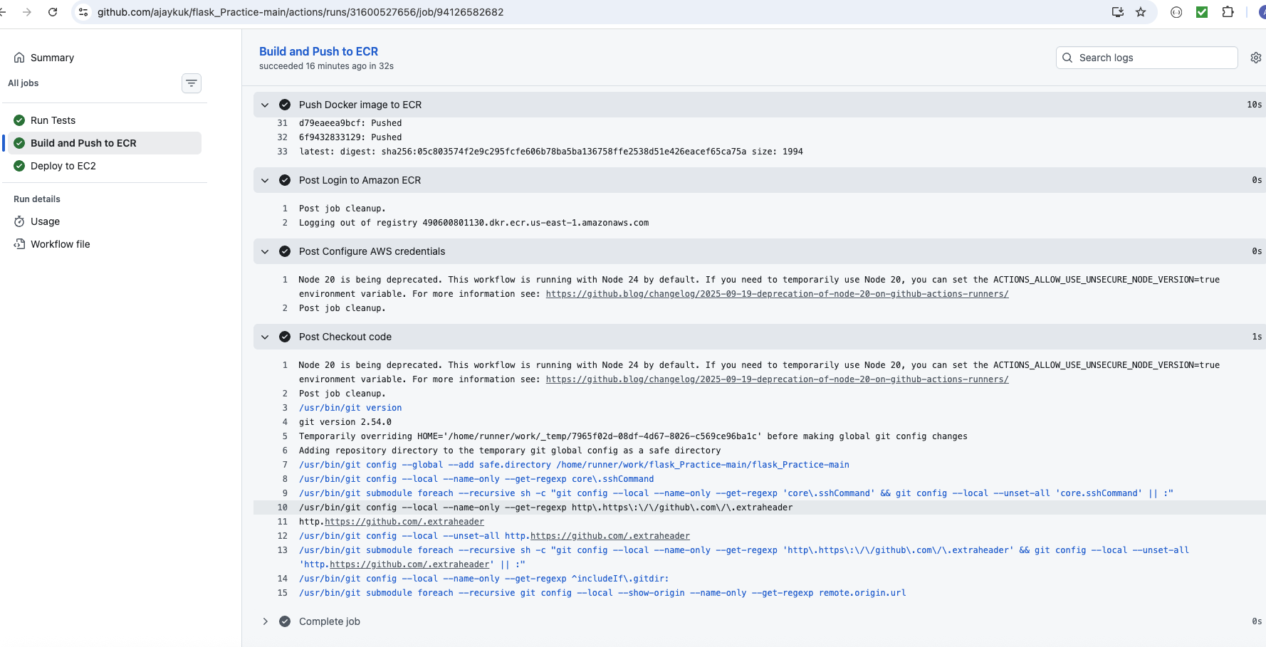

Deploy To EC2 Screen Prints:
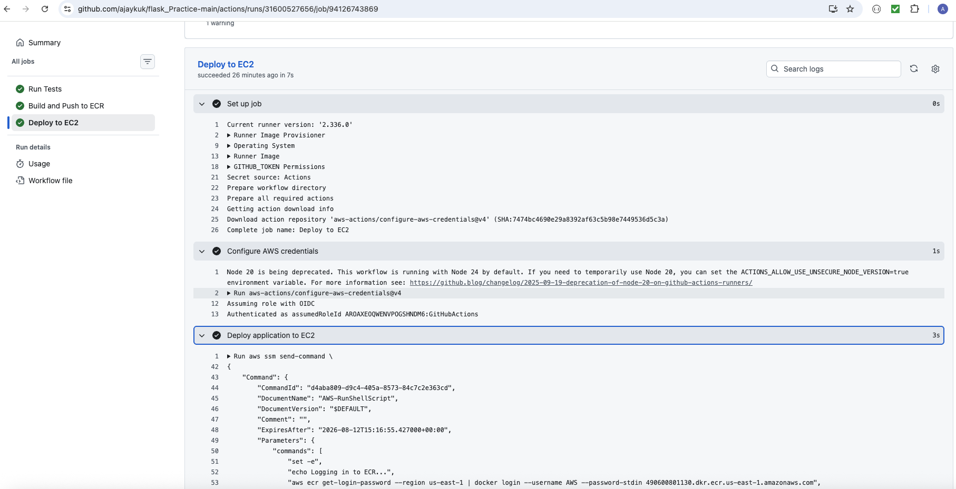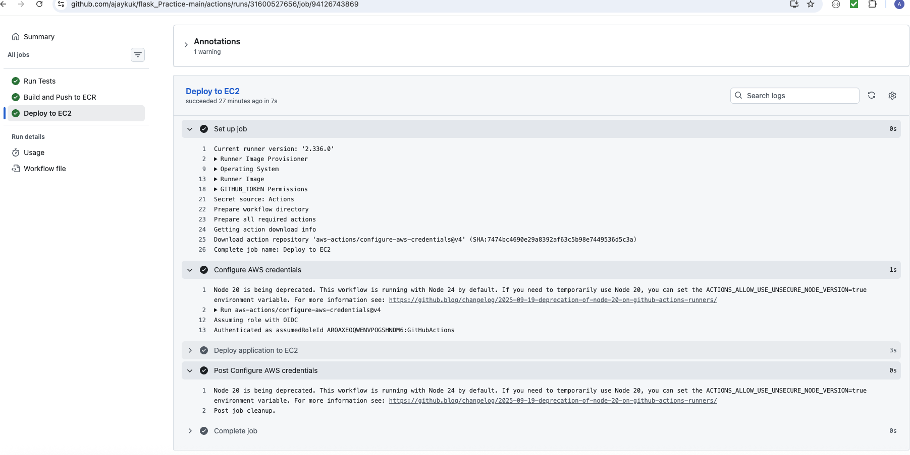

Email notification for job succeeded:
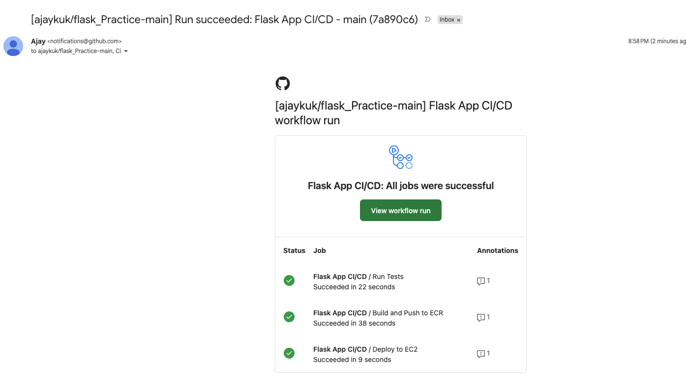

Email notification for failed run:
